ELECTROCHEMICAL CELLS

BEHAVIOUR OBJECTIVES
At the end of this lesson, students should be able to;
- differences between electrochemical and electrolytic cell.
- define standard electrode potential.
- list 2 factors affecting electrode potential of a metal.
- draw and label an electrochemical cell.
- mention 5 types of electrochemical cells.
- calculate the e.m.f of a cell.

ELECTROCHEMICAL CELLS
A set-up in which chemical energy is converted to electrical energy. A typical electrochemical cell consists of two electrodes (cathode and anode) and their electrolytes. Here, the electrodes are connected by means of a salt bridge.
Electrode is a metal dipped into a solution of its salt. In Electrochemical cells, the Anode is the negative electrode while Cathode is the positive electrode.
Salt Bridge is the filter paper soaked in NaCl, KCl,NH₄NO₃ used to complete the electric circuit and allows the movement of ions from one half cell to another.

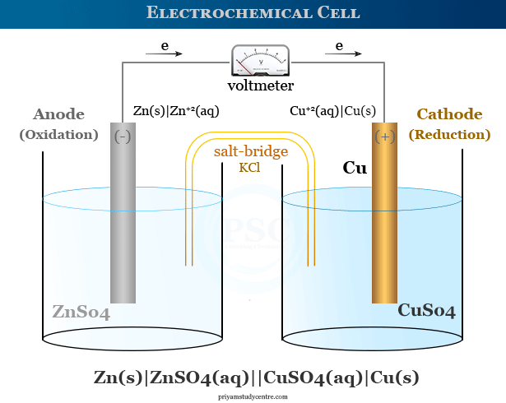

DIFFERENCES BETWEEN ELECTROLYTIC CELL AND ELECTROCHEMICAL CELL
Electrolytic Cell | Electrochemical Cell
Converts electrical energy to chemical energy.  Cathode is the negative electrode while anode is the positive electrode.  No salt bridge is required.  The electrolyte may not contain ions of the metal electrode used. | Converts chemical energy to electrical energy.  Anode is the negative electrode while cathode is the positive electrode.  Salt bridge is required.  The electrolyte must contain metal ions of metal electrode used.

ELECTRODE POTENTIAL: the potential difference set up between the metallic electrode and a solution of its ions (electrolyte solution). It is a measure of the ability of an atom or ion to gain electrons at the electrode.
Case 1: when a metal plate is placed in a solution containing its ions, some of the atoms from the metal place will ionize and go into solution as positively charged ions.
M_{(s)} → M⁺_{(aq)} + e⁻ (Oxidation)
That is: M_{(s)} / M⁺_{(aq)}
Case 2: at the same time, some of the metallic ions in solution will take up electrons from the metal plate and deposit themselves as neutral atoms on the plate.
M⁺_{(aq)} + e⁻ → M_{(s)} (Reduction)
That is: M⁺_{(aq)} / M_{(s)}

FACTORS THAT AFFECTS THE ELECTRODE POTENTIAL OF AN METAL
- Concentration of ions in the solution
- Temperature
- Overall energy change

STANDARD ELECTRODE POTENTIAL
The standard electrode potential of a metal ions/metal system is the potential difference set up between the metal and its ion compared to the electrode potential of H⁺_{(aq)} and H₂ gas system.
Standard electrode potential (Eº) is used to compare the electrode potential values of different metal ions/metal system.

Standard electrode potentials (Eº) of some common metal ions/metal system
Metal ions / metal | Eº
K⁺_{(aq)} / K_{(s)}  Ca²⁺_{(aq)} / Ca_{(s)}  Na⁺_{(aq)} / Na_{(s)}  Zn²⁺_{(aq)} / Zn_{(s)}  2H⁺_{(aq)} / H_{2(g)}  Cu²⁺_{(aq)} / Cu_{(s)}  Ag⁺_{(aq)} / Ag_{(s)}  Au⁺_{(aq)} / Au_{(s)} | -2.92V  -2.87V  -2.71V  -0.76V  0.00V  +0.36V  +0.80V  +1.68V

Note: the electrode potential value is positive, if electrons flow from the hydrogen electrode to the metal electrode and negative, if electrons flow from the metal electrode to the hydrogen electrode.

TYPES OF ELECTROCHEMICAL CELLS
- Primary Cells: (the use-and-throw galvanic cells). They do not produce steady current , and the chemical reactions in the cells are irreversible, i.e. the cells cannot be recharged. So, the cells stop producing an electric current once the reactants are completely depleted. e.g. Alkaline battery, Daniel cell, Leclanche cell.

- Secondary Cells: (rechargeable batteries). They produce steady current, and the electrochemical reactions that takes place in the cells are reversible. i.e. the cells can be recharged. e.g. phone and lamp batteries, lead accumulator, fuel cells, lead-acid batteries, car battery.

CELL NOTATION
The cell notation gives the direction of reaction. By conversion, the anode reaction is written first on the left, the cathode reaction on the right separated by double lines.
X/X^{n+} // Y^{n+}/Y
The single line signifies phase boundary (between metal and its ions in solution), and the double line signify the salt bridge.
Usually, the anode element is higher in the electrochemical series (more reactive) than the cathode (less reactive).
For instance;
Zn_{(s)} / Zn²⁺_{(aq)} // Cu²⁺_{(aq)} / Cu_{(s)}
At the anode: Zn_{(s)} → Zn²⁺_{(aq)} + 2e⁻
At the cathode: Cu²⁺_{(aq)} + 2e⁻ → Cu_{(s)}
Cell equation: Zn_{(s)} + Cu²⁺_{(aq)} → Zn²⁺_{(aq)} + Cu_{(s)}

ELECTROMOTIVE FORCE OF A CELL (E.M.F)
It is the algebraic difference between the two electrode potentials, when two half-cells are joined together through a salt bridge. It is used to predict whether a reaction will occur spontaneously or not. A reaction will be spontaneous if the Eº cell is positive and non-spontaneous if the Eº cell is negative.
The standard emf of a cell is:
Eº cell = Eº reduced - Eº oxidized
= Eº cathode - Eº anode
= Eº right - Eº left

Ex: Calculate the e.m.f of the Daniel cell represented by the cell notation:
Zn_{(s)} / Zn²⁺_{(aq)} // Cu²⁺_{(aq)} / Cu_{(s)}
Given that: Zn²⁺_{(aq)} + 2e⁻ → Zn_{(s)} Eº = -0.76V
Cu²⁺_{(aq)} + 2e⁻ → Cu_{(s)} Eº = +0.34V
Solution
Oxidation: Zn_{(s)} → Zn²⁺_{(aq)} + 2e⁻ Eº = -0.76V
Reduction: Cu²⁺_{(aq)} + 2e⁻ → Cu_{(s)} Eº = +0.34V
Eº cell = Eº reduced - Eº oxidized
= +0.34 – (-0.76)
= +0.34 + 0.76 = +1.10V

DRILL QUESTIONS
- Energy conversion in a galvanic cell is _______?
- Electrical to chemical
- Chemical to electrical
- Electrical to mechanical
- Chemical to mechanical

- Consider the cell representation below;
Zn_{(s)} / Zn²⁺_{(aq)} // Cu²⁺_{(aq)} / Cu_{(s)}

Which of the following statement is correct about the cell?
- Zn is oxidized to Zn²⁺
- Cu is oxidized to Cu²⁺
- Each single line represents a salt bridge
- It is an electrolytic cell

- Is the potential difference set up between the metallic electrode and the electrolyte solution is known as _______?
- Voltmeter
- Lead Accumulator
- Electrode Potential
- None of the above

- In an electrochemical cell, the cathode is the ---------- electrode
- Negative
- Positive
- Neutral
- Charged

- Which of the following is NOT a factor that affects the electrode potential of a metal?
- concentration of ions in the solution
- temperature
- overall energy change
- time taken

ANSWER
- B
- A
- C
- B
- D

